Andre Hardy– Project 4-1

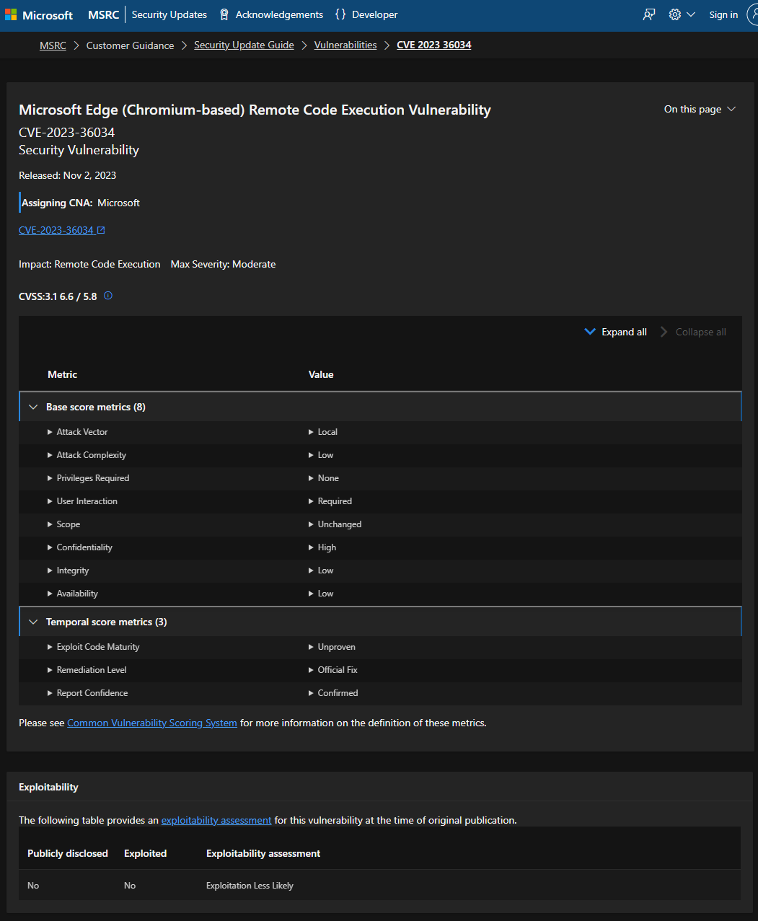

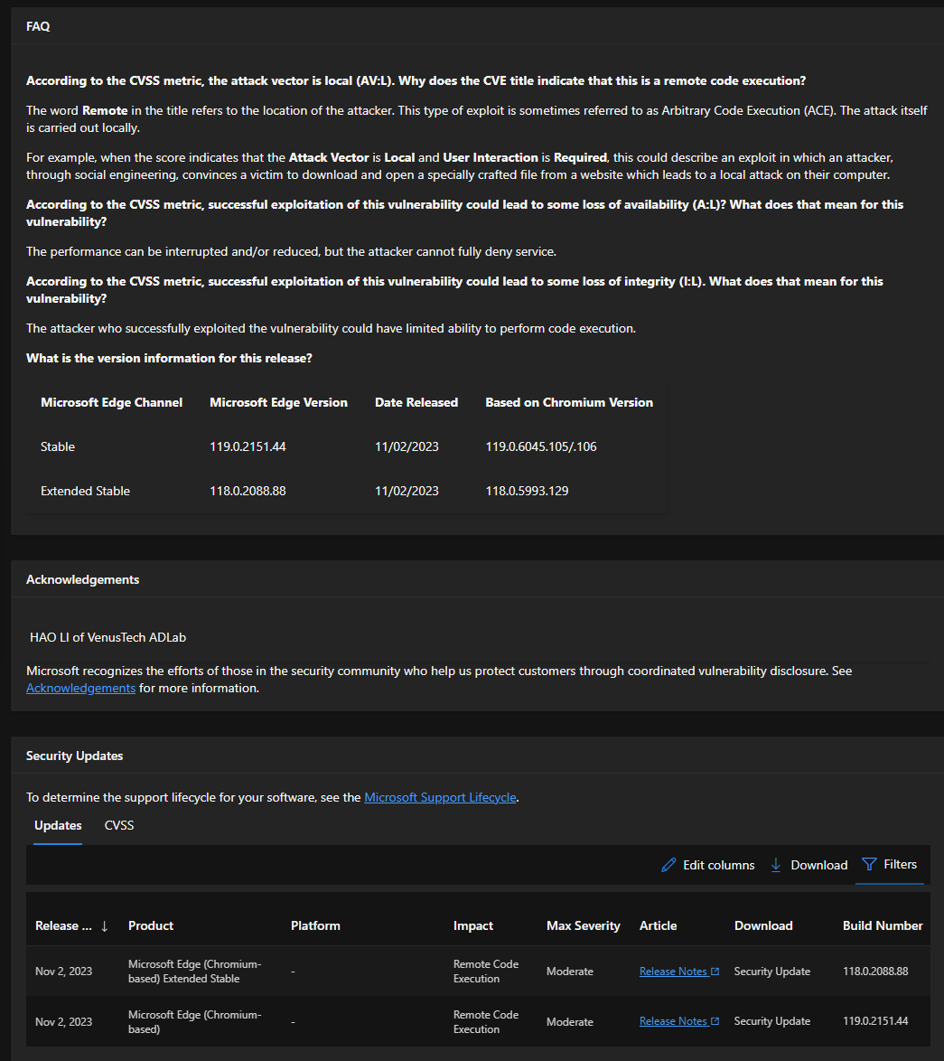

12. How useful is this information? Is it presented in a format that is helpful?
A: The information itself is helpful if you can read it, I believe the format makes it a bit difficult to follow.
14. Read the information under exploitability Assessment (if the exploit you selected does not list an Exploitability Assessment, then select another that does include the assessment). What does this mean? Open another tab on your web browser, and search for Microsoft exploitability Index. Read through the description that you find and keep this tab open.
A: The exploitability assessment may help customers evaluate risk for vulnerability.

15. Return to the Microsoft Security Update Guide and view the exploitability Assessment. How serious is this security vulnerability?
A: the exploitation of this vulnerability is “Less Likely”

16. How important is this information to a security professional? How easy is this online database to use?
A: The information itself is helpful if you can read it, I believe the format makes it a bit difficult to follow.

18. Scroll down through the list of Apple security updates. How does this list compare with the updates from Microsoft?
A: This list is broken up by device and/or OS and is much easier to follow.

19. Select a recent event under Name and information link. Read the information about the update. How does this information compare with Microsoft’s information? Why is there such a difference? Which provides better information for security professions?
A: The information in my opinion is a lot more direct. The difference may be caused by Apple’s proprietary modules in their product as these seem to be much more specific. I believe neither provides “better” information as they are both vendor-specific; Both should be used if applicable.

